

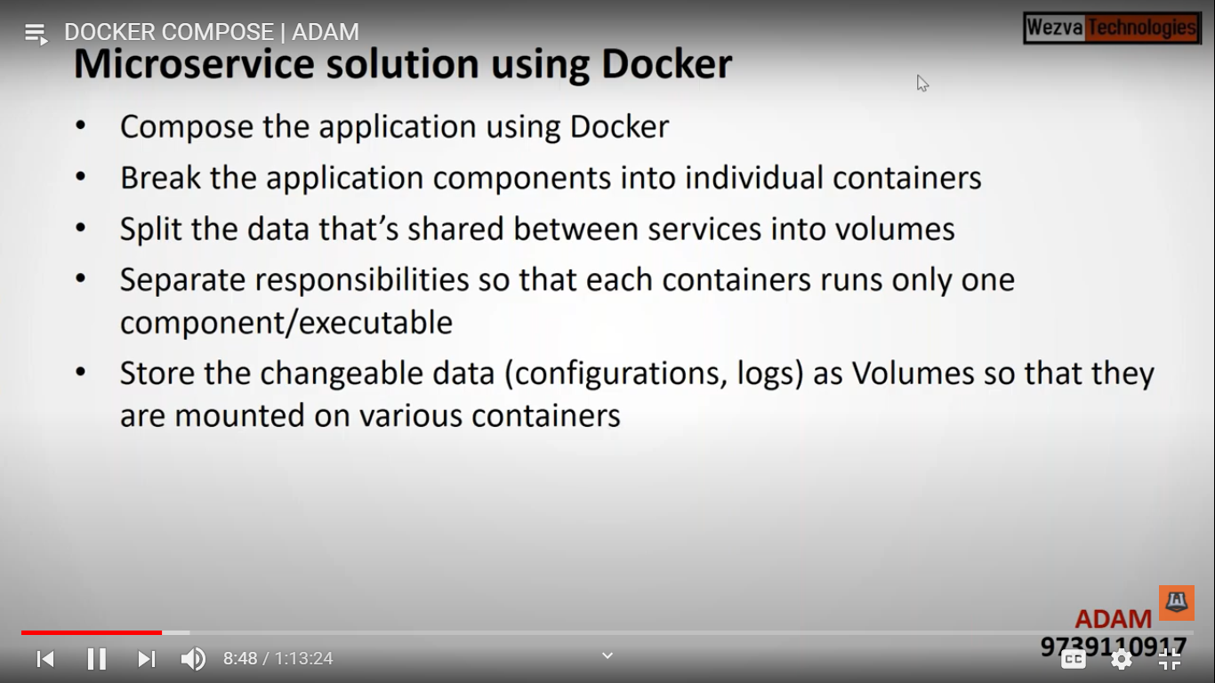

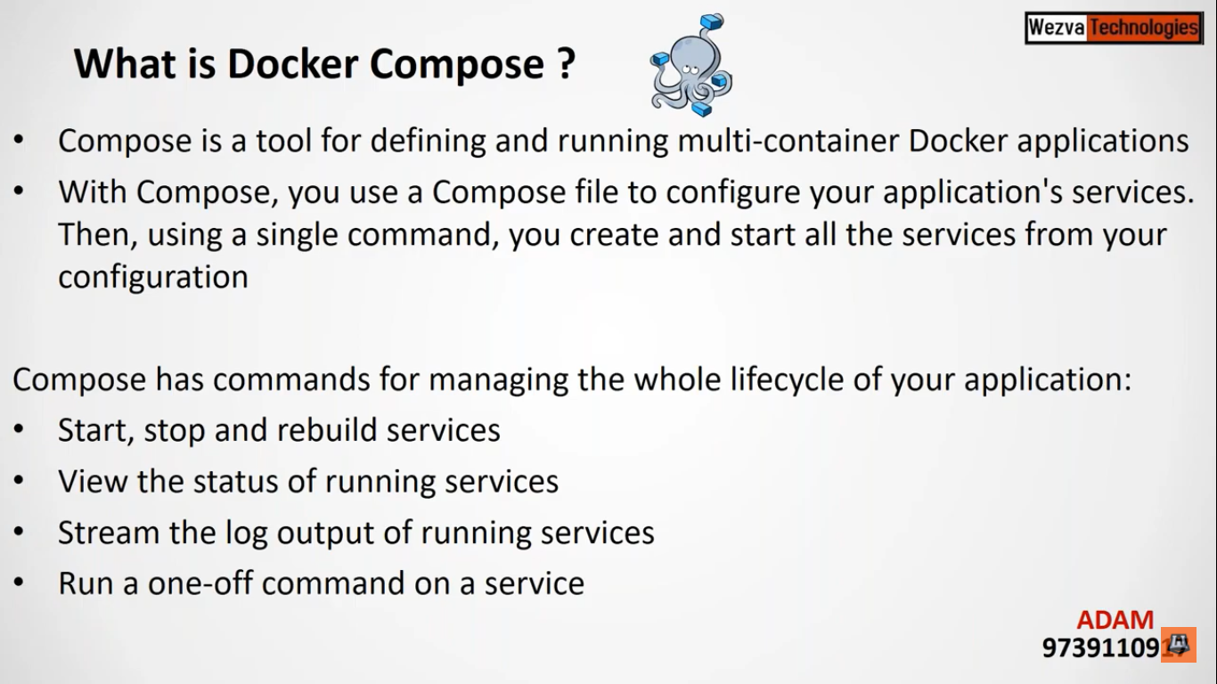

Docker compose will be used where we required multiple container docker applications

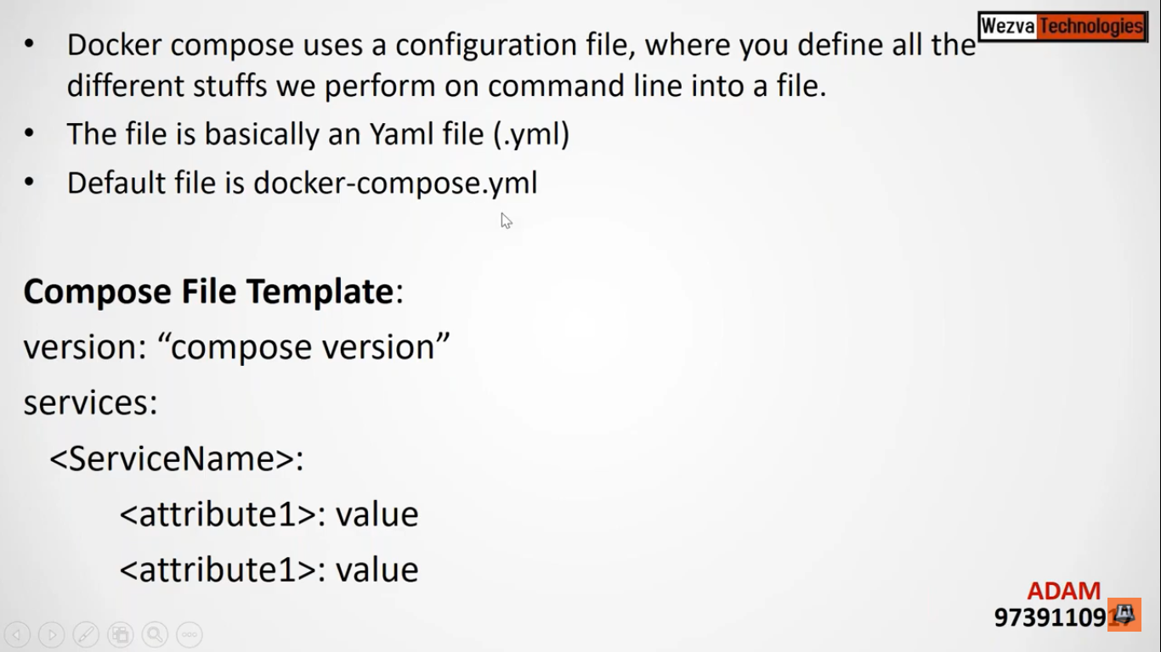

Overview of yml file

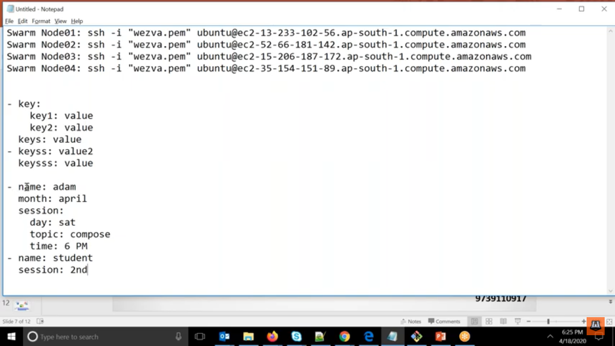

Here – means it is a section.

Parent and child

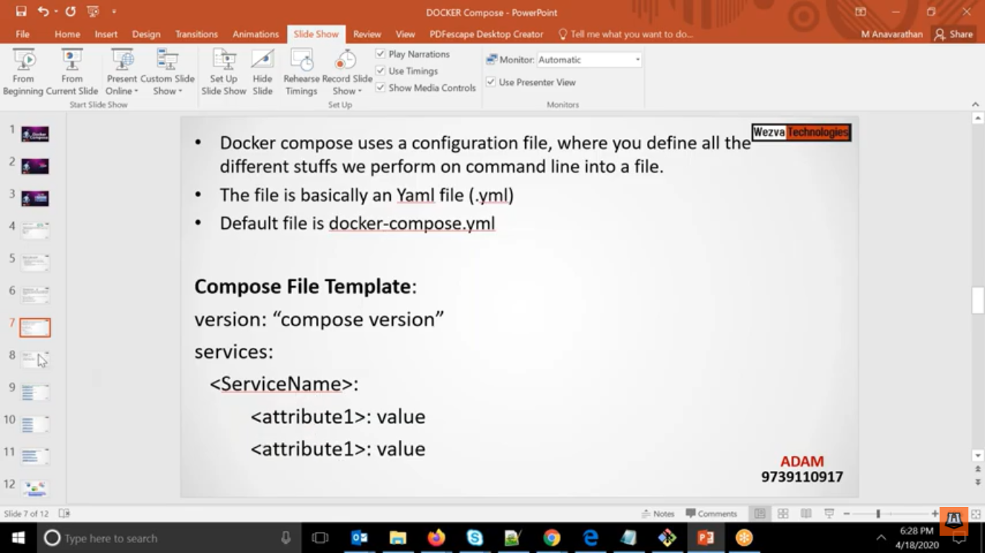

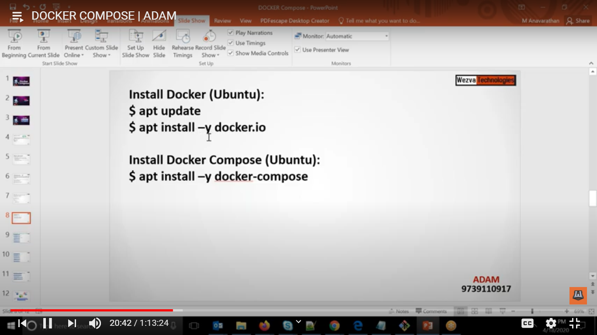

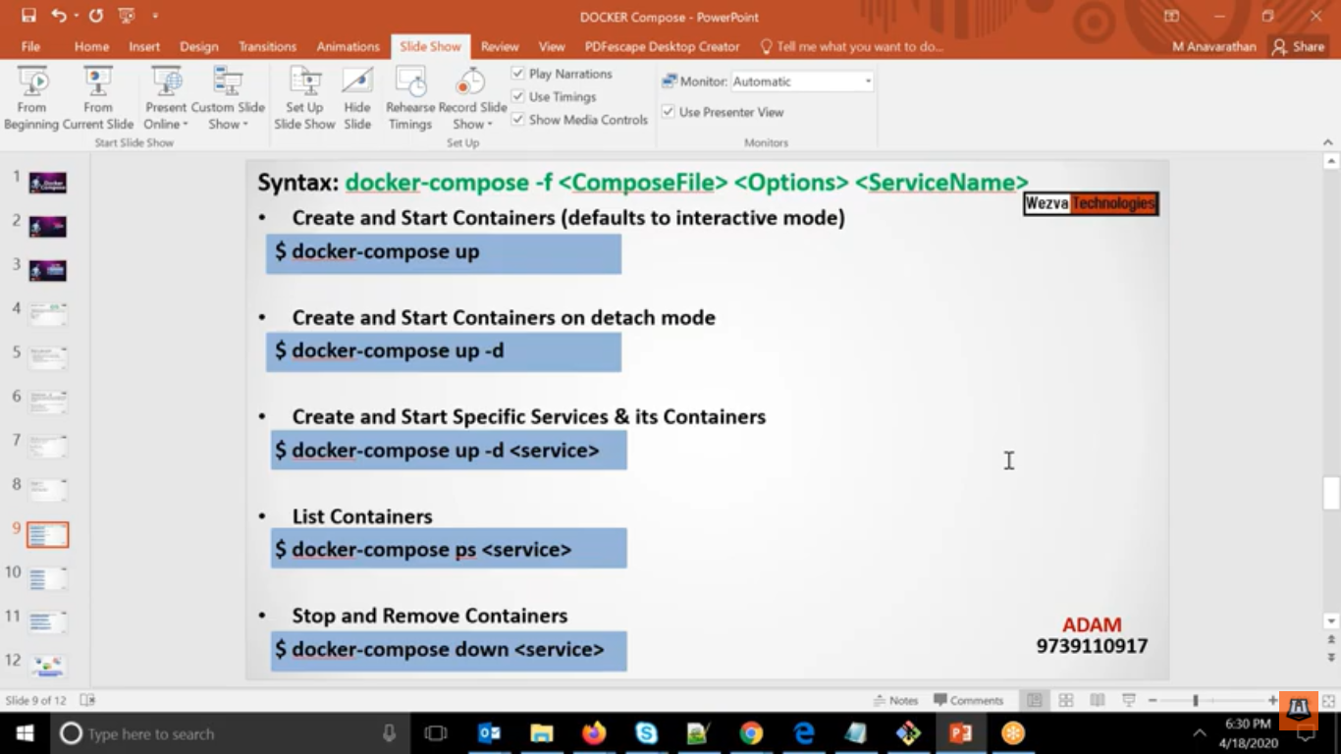

Using Docker-compose not only you can create container but build a image as well

Here docker-compose up is the command for doing all work like docker run.

Here up will first create the image and using that image it will create the container by default it will create container in attach mode,

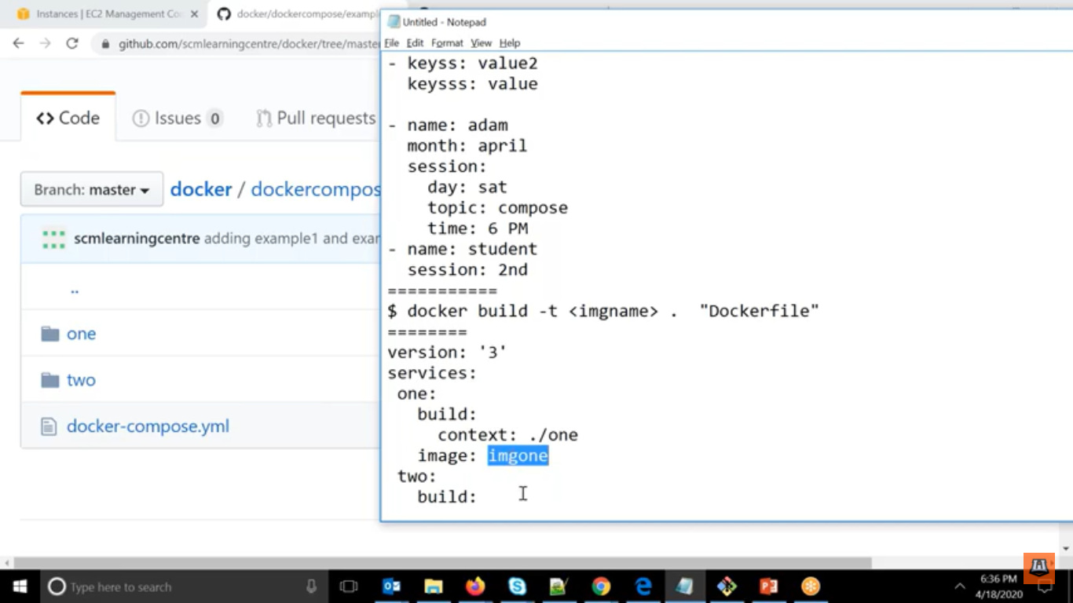

Here what we are doing that similar docker build command here we are giving it under the services

Here we have 2 services.

One and two.

Here we are telling to go to the one folder and create image with image name imgone and once created create a container with same image.

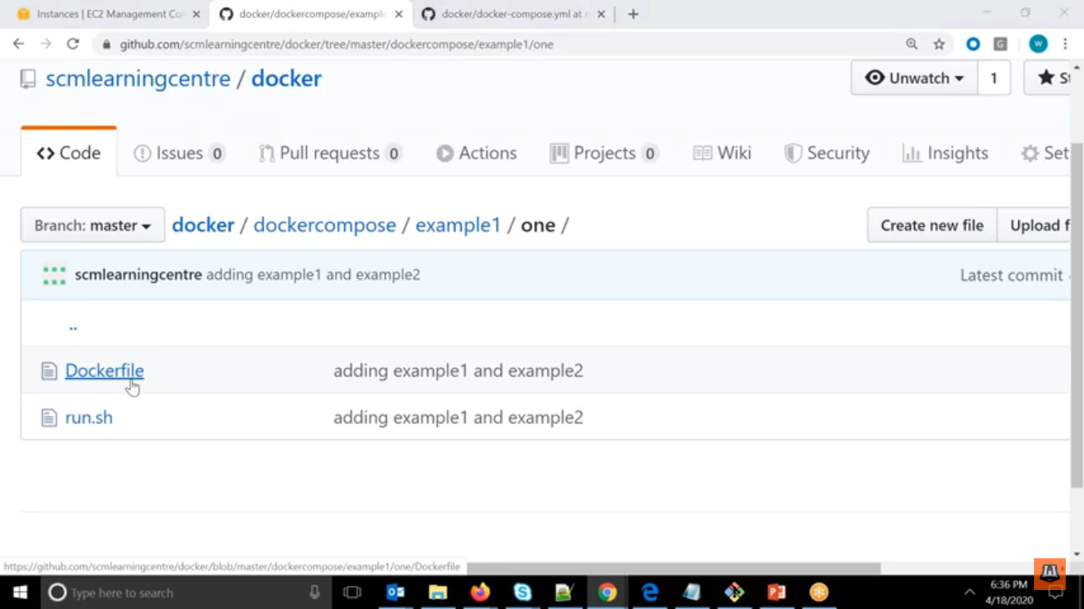

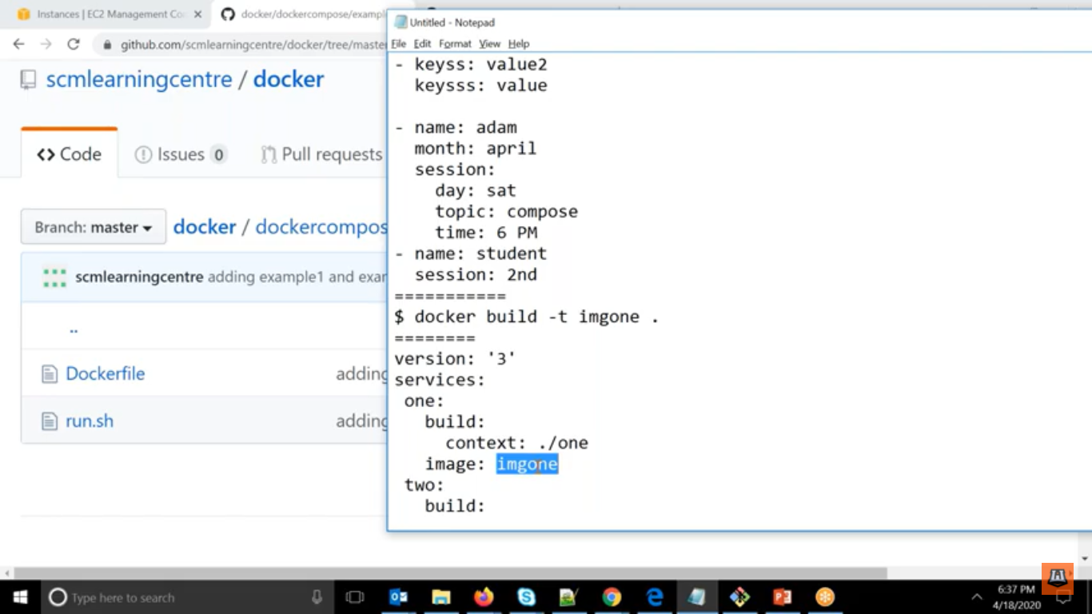

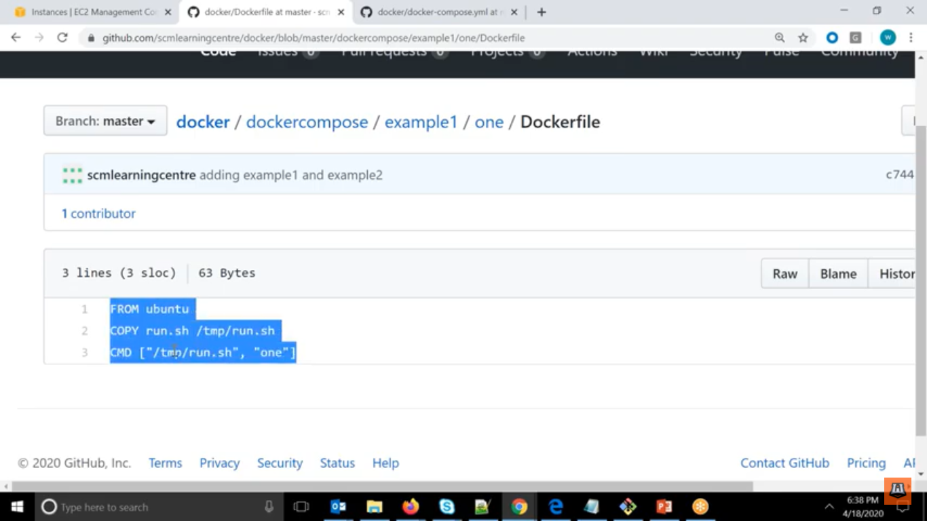

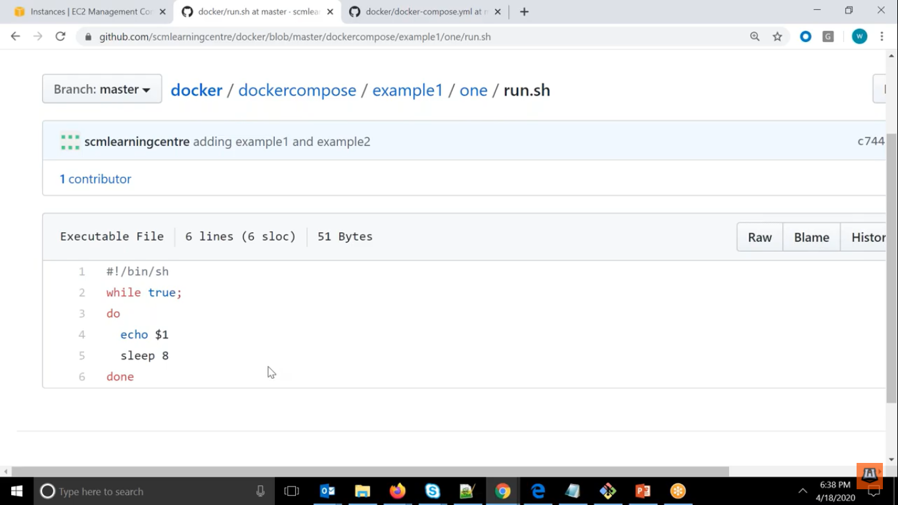

See the examples below

Here it will pick he docker-compose.yml

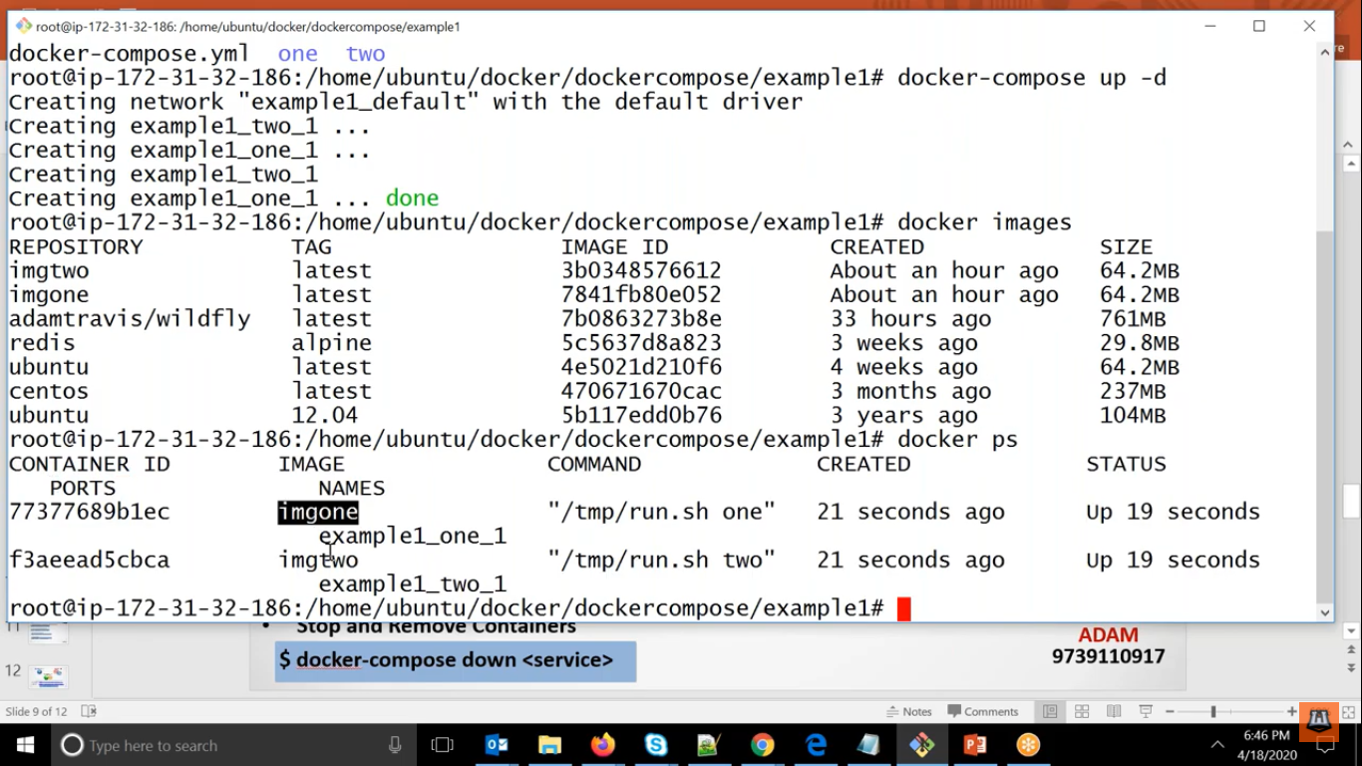

For deleting

Here docker-compose down

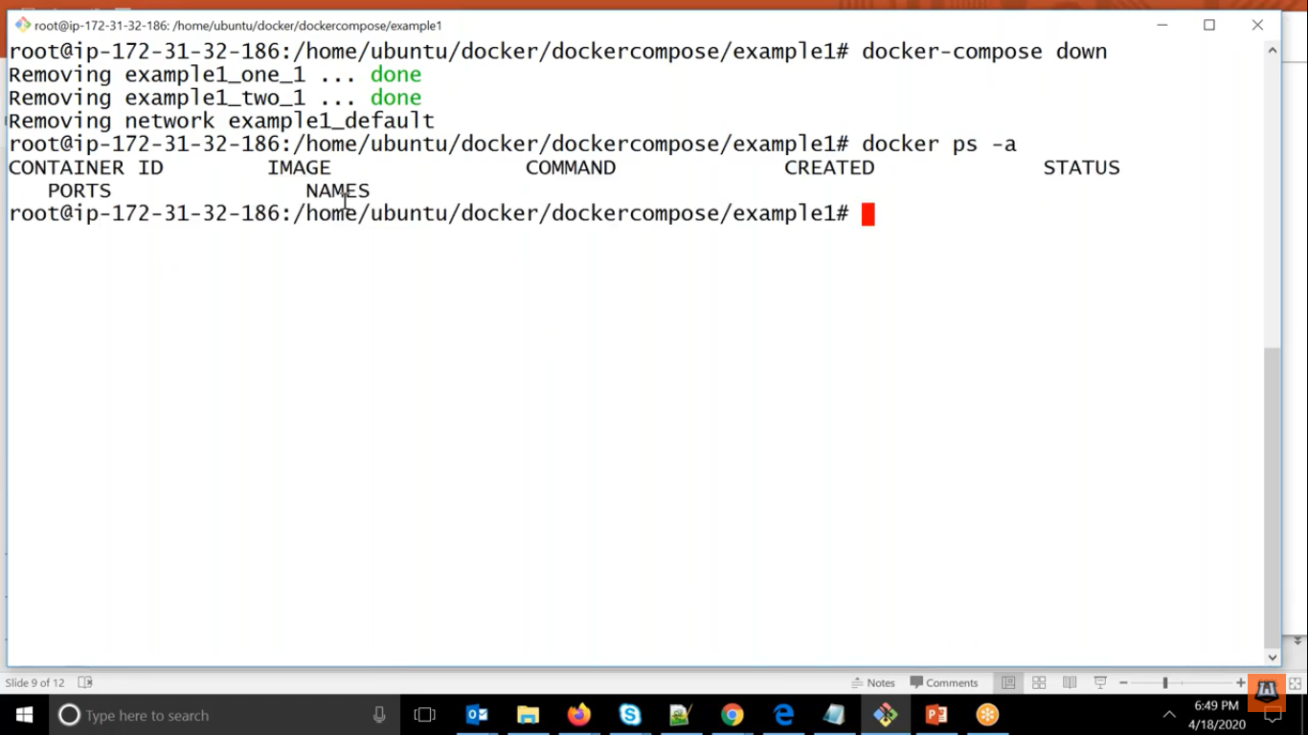

For specific service

We can give the service name.

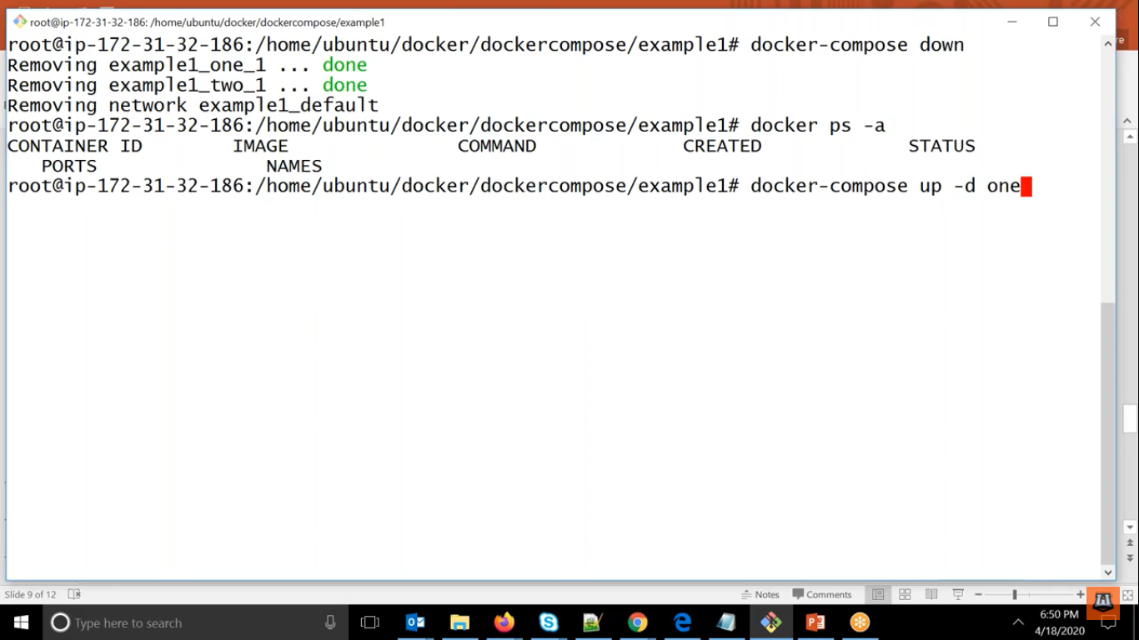

Using docker-compose you can see all the containers available inside the yml.

For checking the container one..

Here docker-compose ps one

For seeing logs

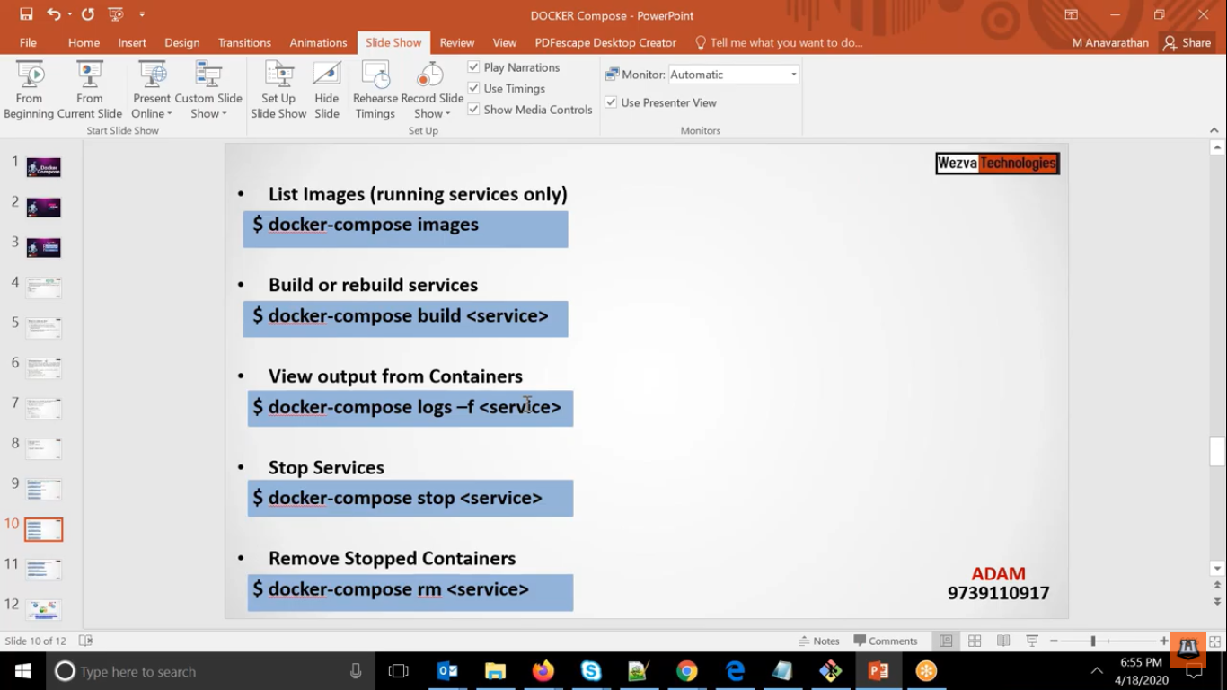

For first service

docker-compose logs -f one

for 2nd service

docker-compose logs -f two

if not mention service it will show all the services available in yml file

Here if you want to stop and delete simultaneously

Here docker-compose down

Otherwise if you want only stopped and then delete

docker-compose stop

docker-compose rm

Here docker-compose up -d then here it will check the image and it will use that image and it will not build it

But if you want to build separately

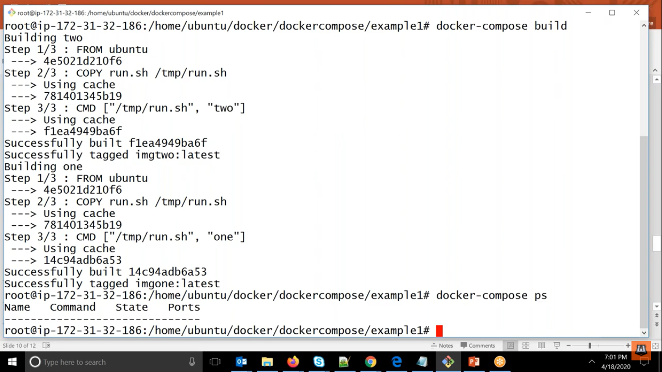

If you want to go inside the detach running containers

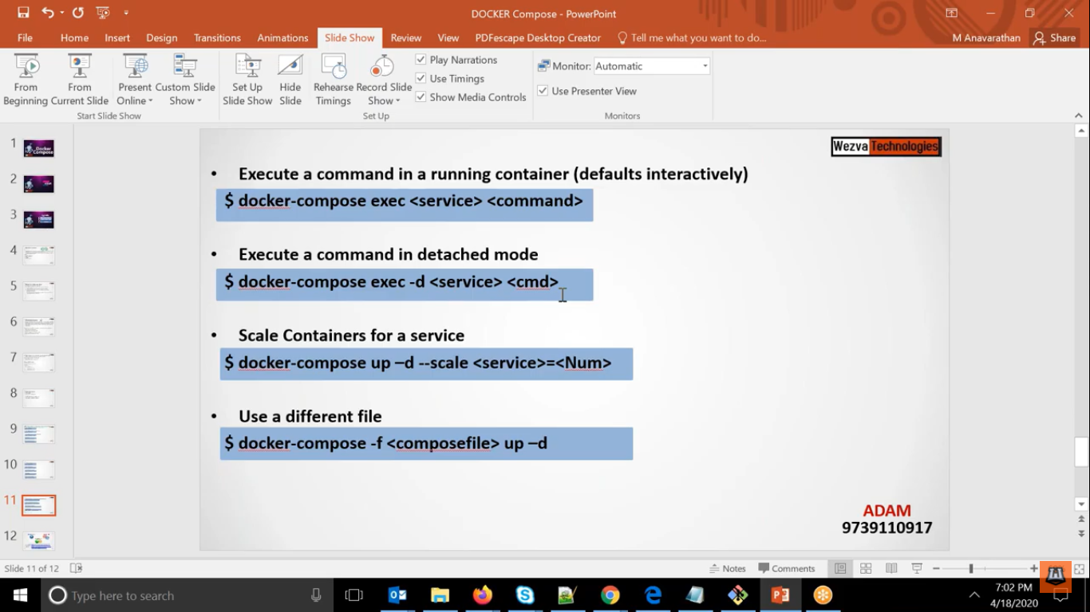

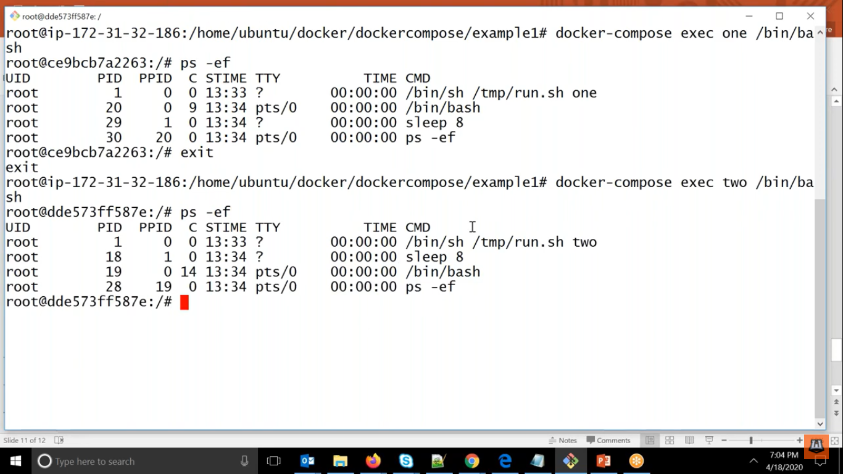

Remember -d should be given before service name.

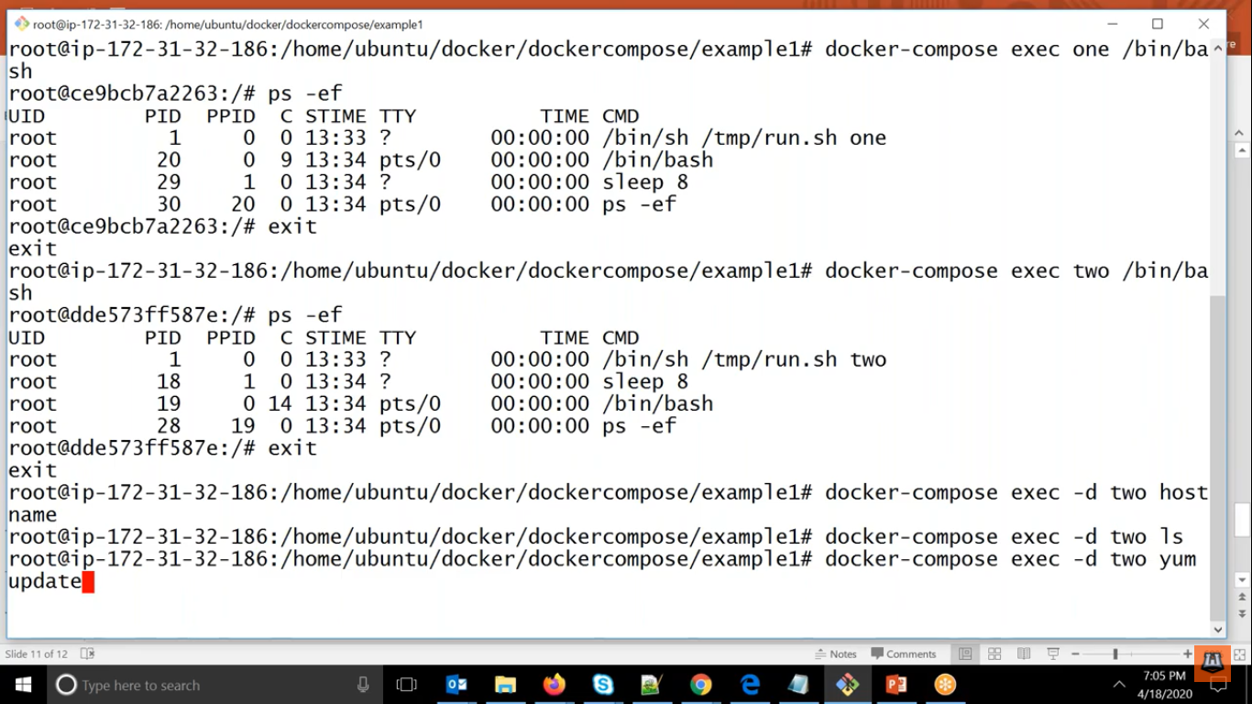

Similarly you can scale up and scale down also.

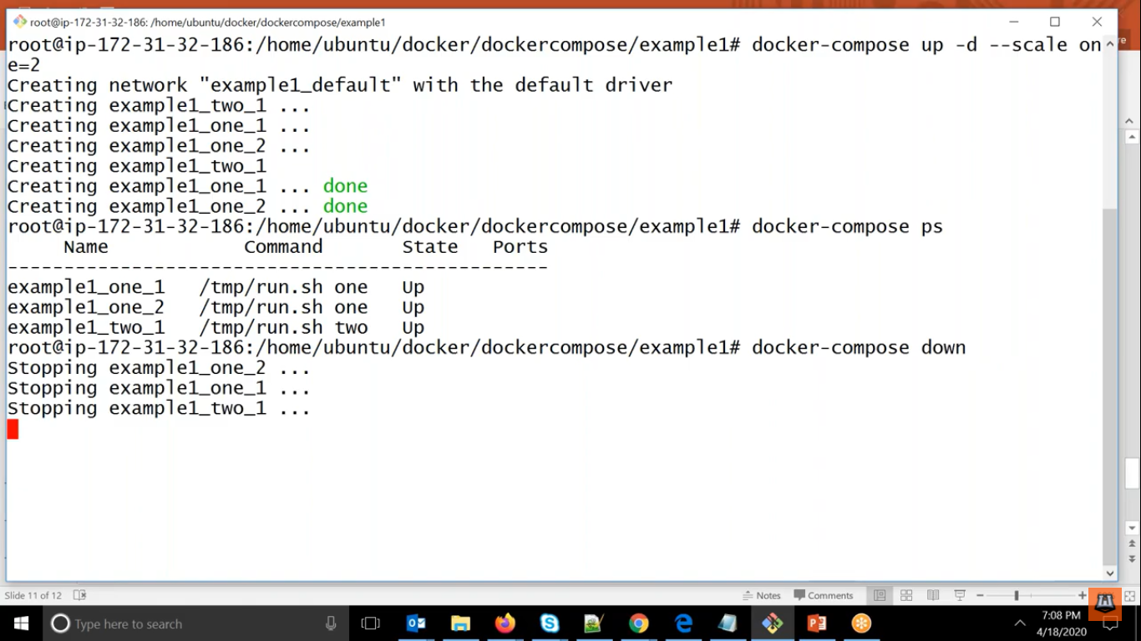

If you want to use different file then

Here docker-compose -f <composfile> up -d

See below example carefully.

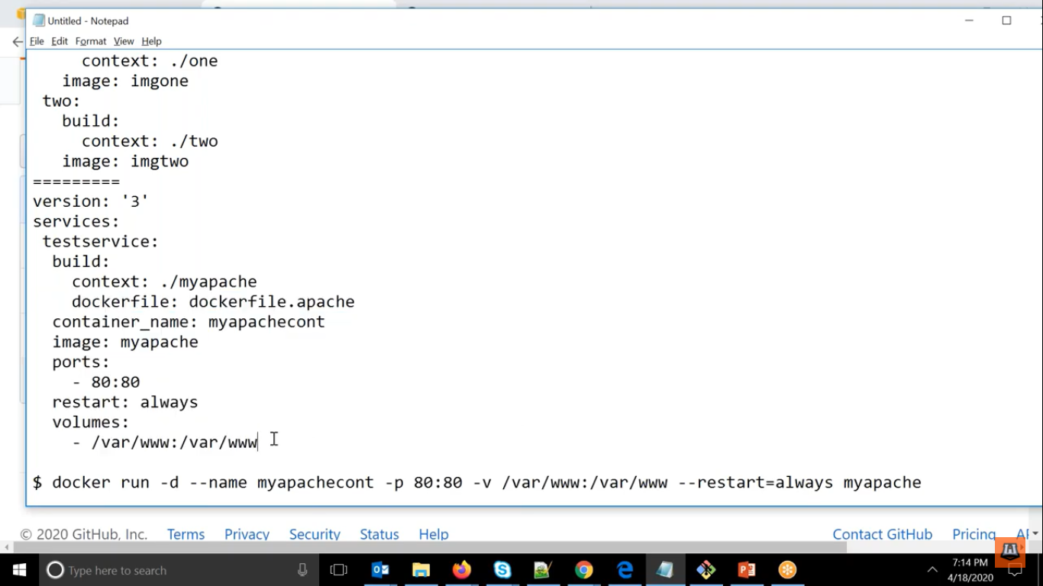

If you want to download the artifactory

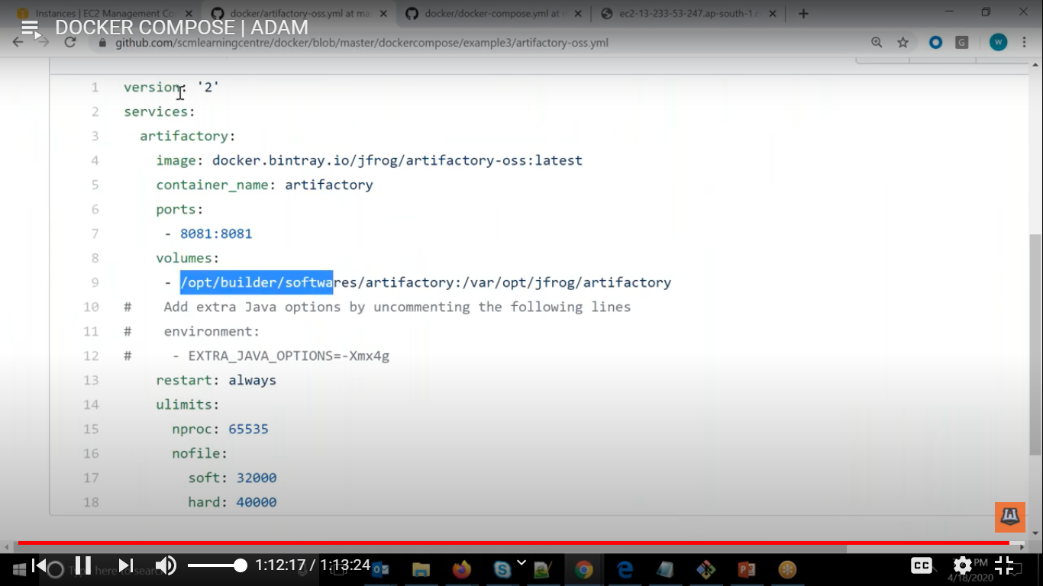

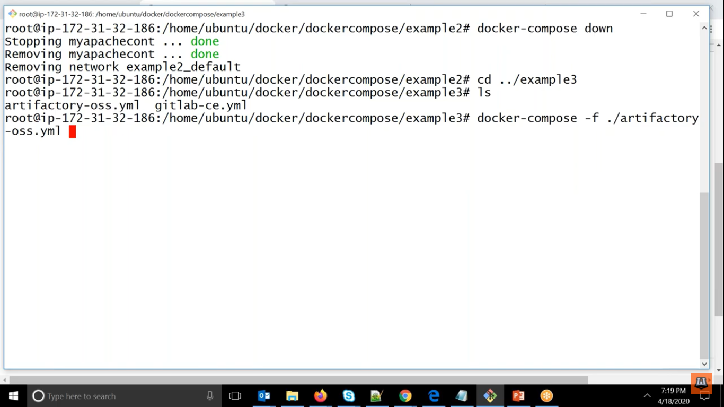

Docker compose utility where if you want to use multiple container at a time